IT FND 110A

Yizhou Yang

Prof. Randal Root

TA: Aayush V. Shah

August 31, 2020

Assignment 08

[https://github.com/effyyangdesign/IntroToProg-Python-Mod07-](https://github.com/effyyangdesign/IntroToProg-Python-Mod08-)

Assignment 07 Step Documentation

**Introduction**

This essay documents the steps I took to finish Assignment 08 to practice class.

**Steps:**

To begin this week’s assignment, I used the listing09.py from the class project as a reference to handle class’s constructor, properties and methods. Replacing “FirstName” and “LastName” to “ProductName” and “ProductPrice” while remaining the structure was able to get me to this point, where I can print out a list. Yet the list is not user readable, like the screenshot attached below.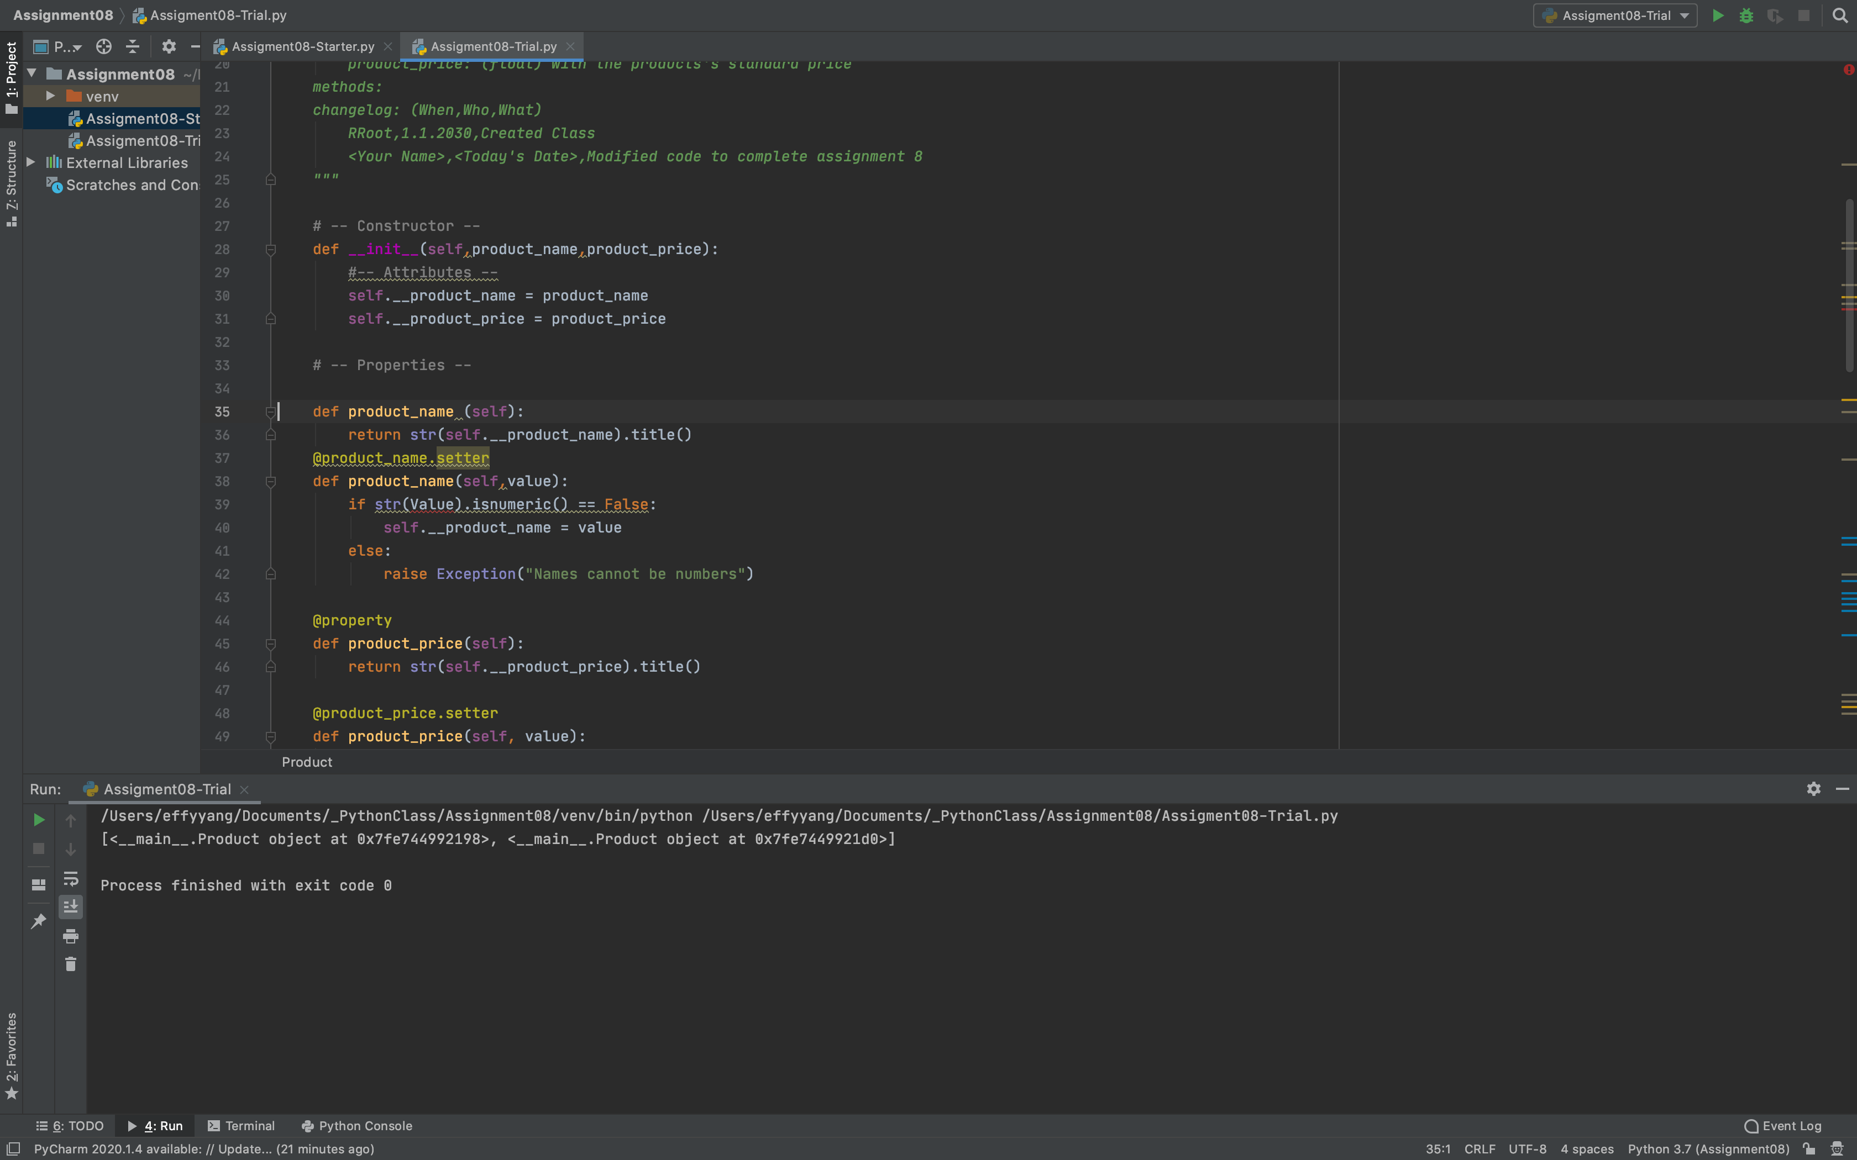

By loading into some value and go through debug process, I was able to see that the value is indeed being saved in the list, yet when I print the list straight out, that was not the desired output.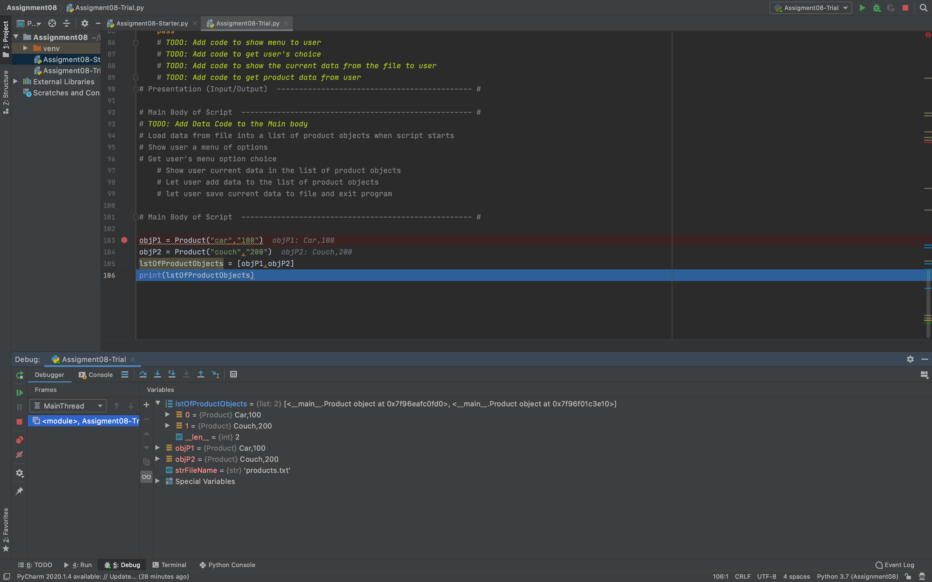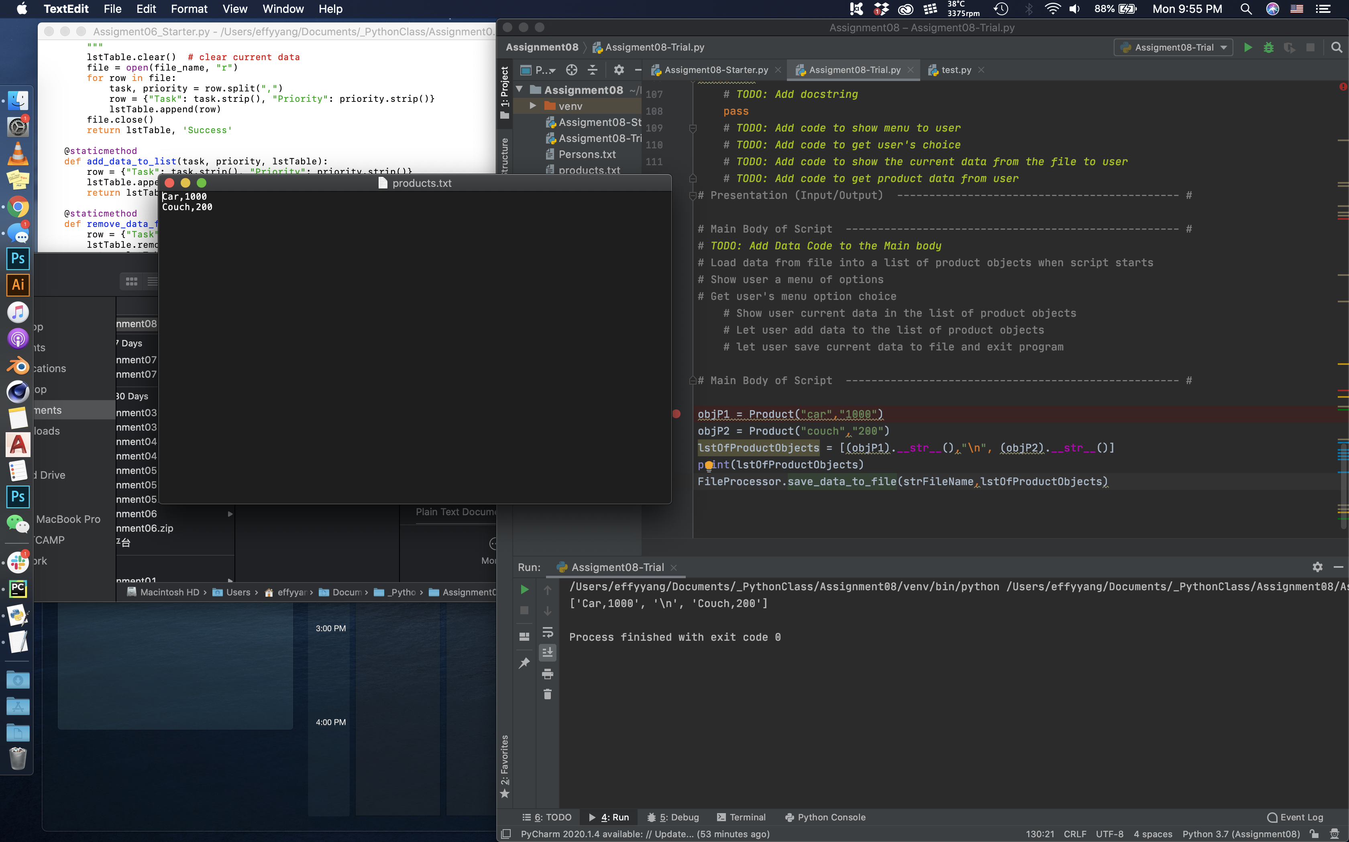

Then I went back and referred to list 16 of page 12 in the lecture notes to find the method of returning the class’s data as a string. After solving that issue, I noticed that the txt file data is being written with in one row, rather than each entry as its own row. After testing some method to add “\n” in different places in order to achieve that format, while not sabotaging the list by introducing non-product info.

In the end, I referenced the following code mentioned on page17 of the lecture notes.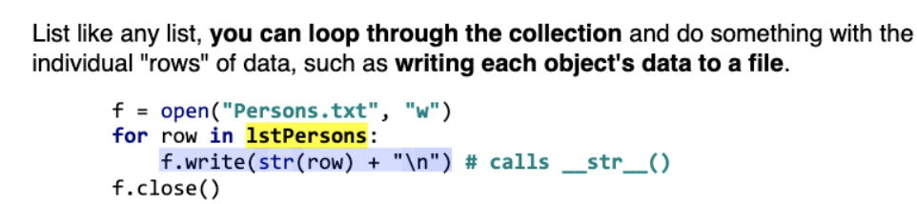

After hard coded value passes through smoothly, I decided to move on to tackle the task of passing through user inputs into the Product Class and engage all function to work properly. In the beginning, no value was being saved properly.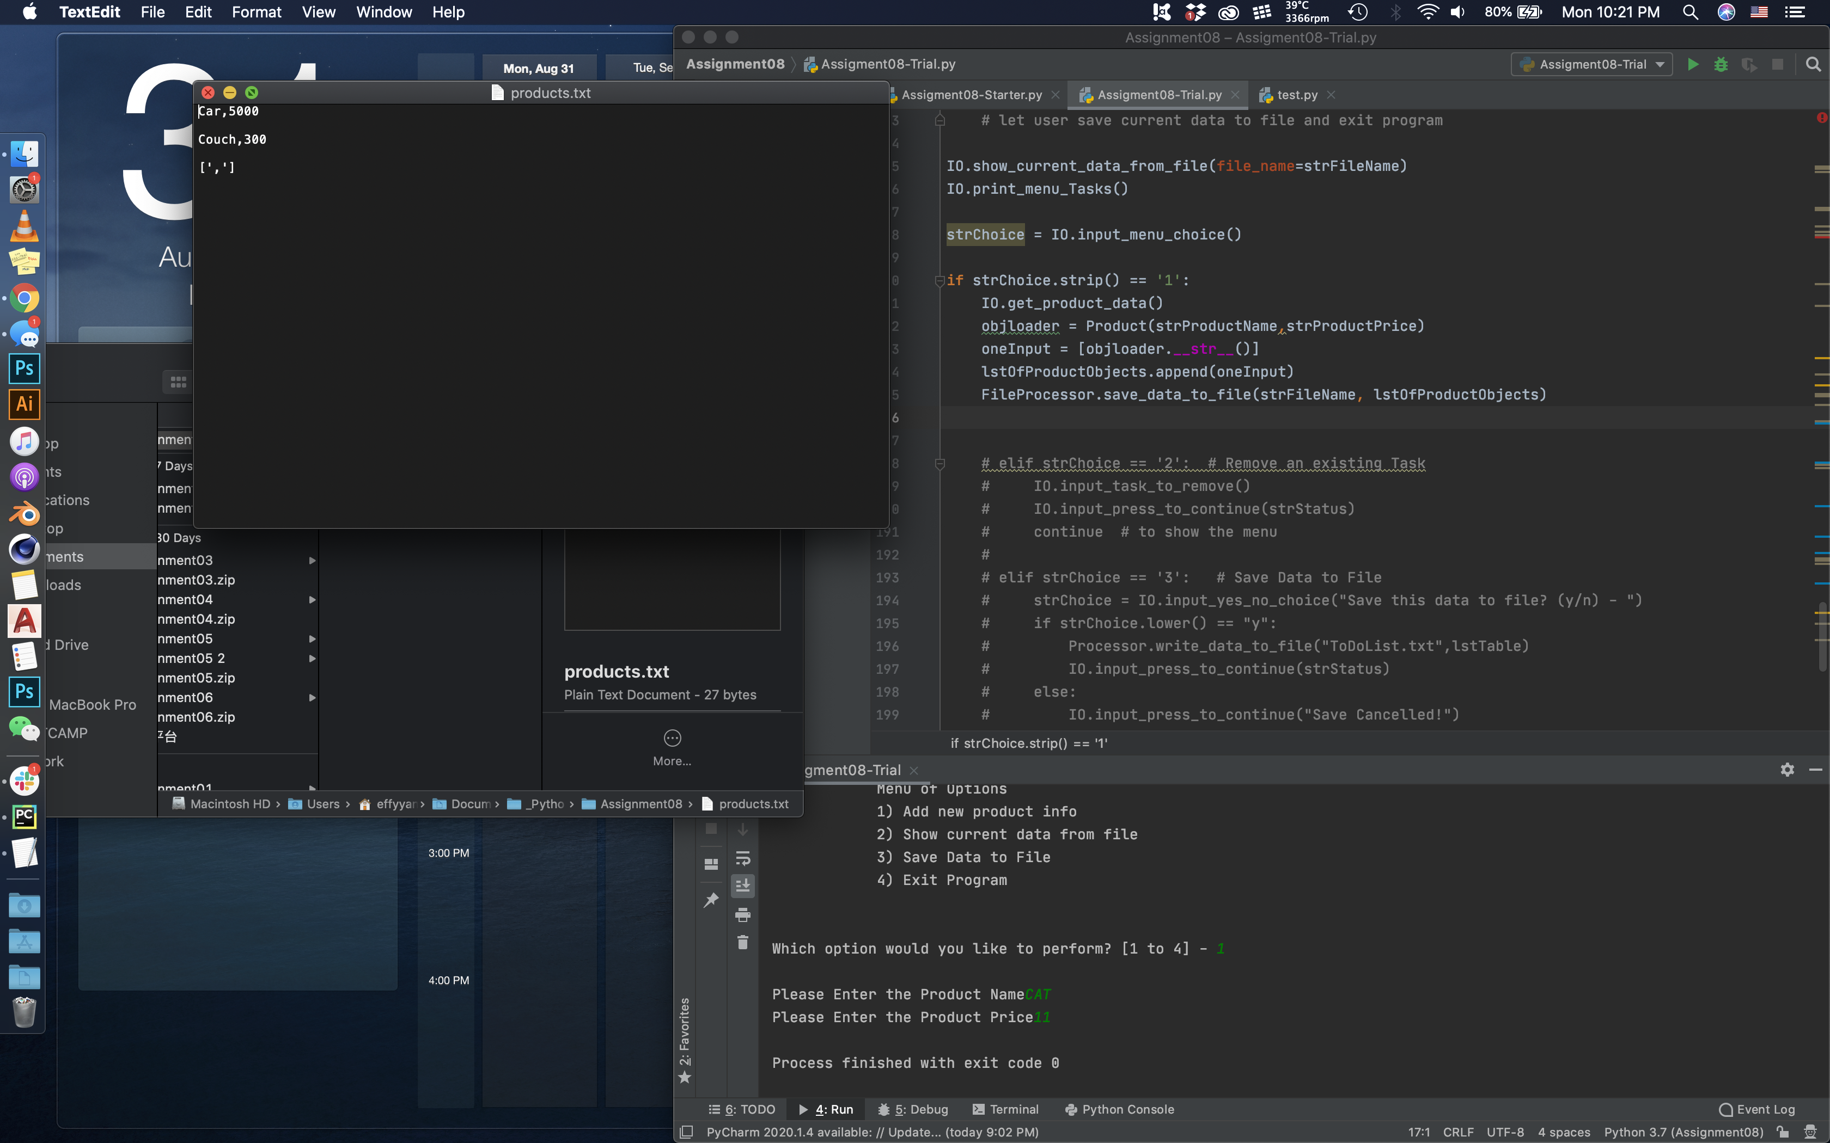

The multiple name of “Product_Name” and “Product_Price” became confusing in deciding which value should be assigned with the user input. After testing multiple options, I was able to get it to ingest the value correctly.

After finishing getting the user input and process it properly, the rest of the functionalities were very similar to assignment 06, therefore, I was able to reference the method and structure used then.

The only remaining question is why, with every process, “\n” seems to repeat multiple time in parts of the process. Debugging along the input function did not yield any discovery in terms of where is this “\n” being repeated. I would love to find out more about this bug after handing in the assignment. 